**INSTITUTE OF ENGINEERING**

ADVANCED COLLEGE OF ENGINEERING AND MANAGEMENT

Kupondole, Lalitpur

**(AFFILIATED TO TRIBHUVAN UNIVERSITY)**



Lab no:4

Subject: DSAP

**Submitted By: Submitted To:**

Department of Computer

and

Electronics Engineering

Name: Sameep Dhakal

Roll no: ACE074BCT063

**Lab:04**

**Title**: LTI SYSTEM

**Objective**: To learn about LTI system and its various signals

**Introduction**:

Linear time-invariant systems (LTI systems) are a class of systems used in signals and systems that are both linear and time-invariant. Time-invariant systems are systems where the output does not depend on when an input was applied. These properties make LTI systems easy to represent and understand graphically. A good example of an LTI system is any electrical circuit consisting of resistors, capacitors, inductors and linear amplifiers. Linear time-invariant system theory is also used in image processing, where the systems have spatial dimensions instead of, or in addition to, a temporal dimension.

Convolution is a mathematical operation which takes two functions and produces. a third function that represents the amount of overlap between one of the functions and a. reversed and translated version of the other function. Convolution is a mathematical operation which takes two functions and produces a third function that represents the amount of overlap between one of the functions and a reversed and translated version of the other function.

1.Determine whether the system is linear or not. Plot the required signals to verify the result.

clc;

clear all;

a1=3;

a2=-7;

n=-3:0.1:3;

x1=n;

x2=sin(n);

y1=x1.^2;

y2=x2.^2;

y3=a1*y1+a2*y2;

x3=a1*x1+a2*x2;

y4=x3.^2;

subplot(2,1,1);

stem(n,y3);

grid on;

title('Non Linear/Sameep Dhakal/563’);

xlabel('n');

ylabel('y3[n]');

subplot(2,1, 2);

stem(n,y4);

grid on;

xlabel('n');

ylabel('y3[n]');

grid on;

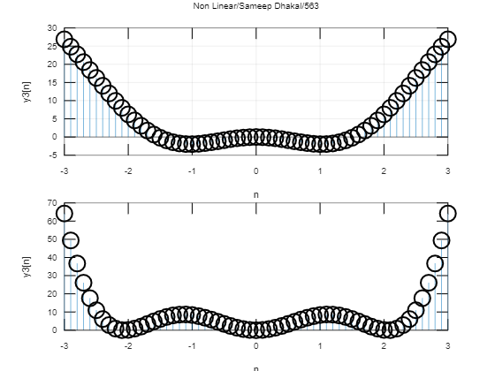

b. y[n]=x[n^2].

clc;

clear all;

a1=3;

a2=-7;

n=-3:0.1:3;

x1=n;

x2=sin(n);

y1=n.^2;

y2=sin(n.^2);

y3=a1*y1+a2*y2;

x3=a1*x1+a2*x2;

y4=a1.*n.^2+a2.*sin(n.^2);

subplot(2,1,1);

stem(n,y3);

grid on;

title(' Linear/Sameep Dhakal/563');

xlabel('n');

ylabel('y3[n]');

subplot(2,1, 2);

stem(n,y4);

grid on;

xlabel('n');

ylabel('y3[n]');

grid on;

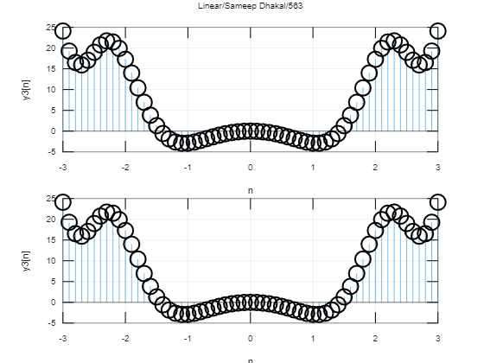

c. y[n]=nx[n]

clc;

clear all;

a1=3;

a2=-7;

n=-3:0.1:3;

x1=n;

x2=sin(n);

y1=n.*x1;

y2=n.*sin(n);

y3=a1*y1+a2*y2;

x3=a1*x1+a2*x2;

y4=n.*x3;

subplot(2,1,1);

stem(n,y3);

grid on;

title('Linear/sameep Dhakal/563');

xlabel('n');

ylabel('y3[n]');

subplot(2,1, 2);

stem(n,y4);

grid on;

xlabel('n');

ylabel('y3[n]');

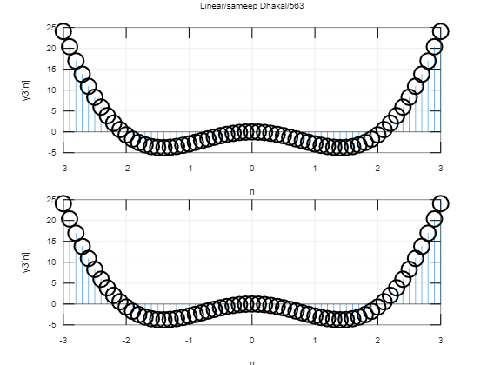

2. Two discrete signals are given as h[n]={1,2,1,-1} and x[n]={1,2,3,1}. Plot these two signals :

i) Without using conv function.

clc;

clear all;

h= [1 2 1 -1];

nh= [-1 0 1 2];

x= [1 2 3 1];

nx= [0 1 2 3];

X= [x, zeros(1,length(h))];

H= [h, zeros(1,length(x))];

n1= length(x);

n2= length(h);

for n=1:n1+n2-1

y(n)=0;

for k= 1:n1

if((n-k+1)>0)

y(n)=y(n)+X(k)*H(n-k+1);

end;

end;

end;

n= min(nh)+min(nx):max(nh)+max(nx);

stem(n,y);

grid on;

title('without convolution function/Sameep Dhakal/563');

xlabel('n');

ylabel('y[n]')

grid on;

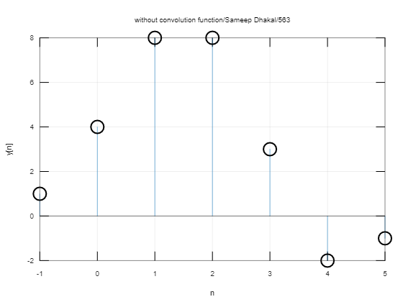

ii) Using conv function.

clc;

clear all;

h= [1 2 1 -1];

nh= [-1 0 1 2];

x= [1 2 3 1];

nx= [0 1 2 3];

y=conv(x,h);

n= min(nh)+min(nx):max(nh)+max(nx);

stem(n,y);

grid on;

title('using convolution function/ Sameep Dhakal/563');

xlabel('n');

ylabel('y[n]')

grid on;

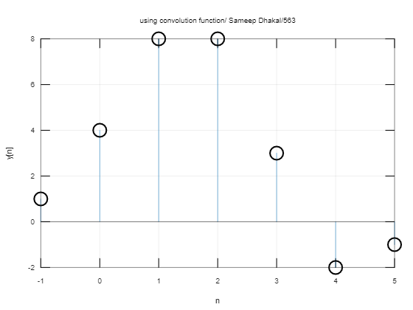

3. Plot the autocorrelation sequence of a sine wave with a frequency of 1Hz, sampling frequency is 200 Hz.

clc;

clear;

A=1;

f=1;

fs=200;

w=2*pi*(f/fs);

t=0:0.001:1024;

x=A*sin(w*t);

subplot(2,1,1);

plot(t,x);

title('auto correlation/SameepDhakal/563');

xlabel('t');

ylabel('x(t)');

grid on;

y=xcorr(x);

subplot(2,1,2);

plot(y);

xlabel('t');

ylabel('y(t)');

grid on;

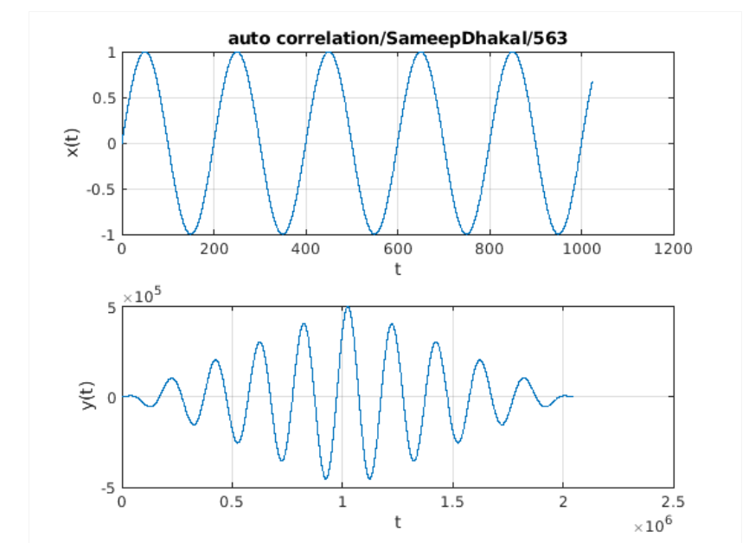

**Discussion and Conclusion** : In this lab we learnt about the applications of LTI system and convolution and plotted various signals.